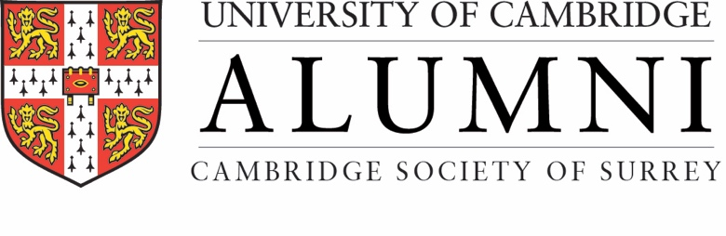
Politics & The Media - What’s Wrong -and Where There Might Be Hope
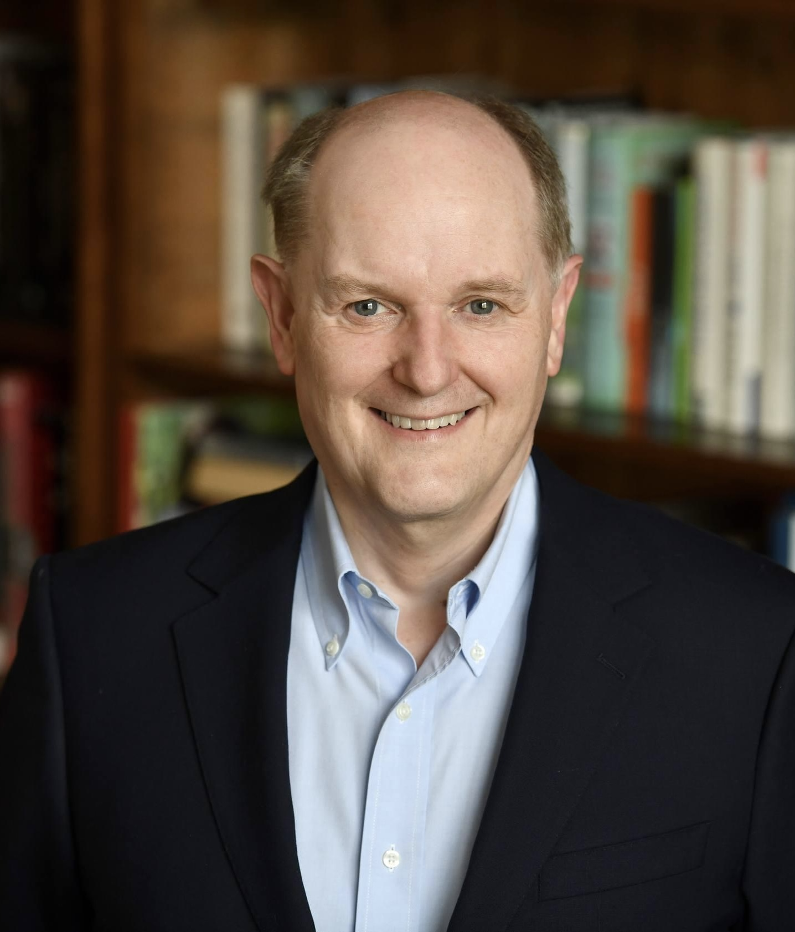

A talk presented by Roger Mosey
on Wednesday 23rd September 2026 at 10.45 for 11.15am
at Tyrrells Wood Golf Club, The Drive, Leatherhead KT22 8QP
Roger Mosey, a former senior BBC news executive and recently Master of Selwyn College, analyses how Britain’s political chaos is amplified by the conventional media and made worse by the extremism seen on social media and asks whether there is a better way forward and cause for hope.

Mosey is a British journalist, broadcaster, and author who spent over three decades in senior roles at the BBC, culminating as editorial director with oversight of television news, sports coverage, and the London 2012 Olympics broadcasting, before becoming Master of Selwyn College. He attended Bradford Grammar School and Wadham College, Oxford, where he studied Modern History and Modern Languages. His upbringing, education, and early interest in sport and broadcasting all shaped the career that followed
His BBC career, spanning 1980 to 2013, included editing the Today programme on BBC Radio 4, serving as controller of BBC Radio 5 Live, heading television news, and directing sports output, where he managed high-profile events emphasizing editorial rigor amid the corporation's public funding model. Post-BBC, he has contributed opinion pieces to outlets across the spectrum, from the Telegraph and Spectator to the New Statesman, often critiquing media impartiality and institutional challenges,
After leaving the BBC, Mosey wrote Getting Out Alive: News, Sport and Politics at the BBC, reflecting on pressure, politics, and editorial decision-making inside the corporation. He has continued to write and broadcast, often commenting on media bias, impartiality, and the need for greater ideological diversity within the BBC. He also recently wrote 20 Things That Would Make the News Better, a definitive exploration of Britain’s news output and what must change if we are to avoid a future of uninspiring news, uninformed decision-making and accountability-dodging politicians.
As Master at Selwyn, Mosey focused on enhancing its inclusivity and accessibility while maintaining its traditional ethos as a "friendly" college, stepping down after a 12-year tenure that included a stint as Deputy Vice-Chancellor.

Roger Mosey is an exceptional media practitioner: his lecture promises to be stimulating and probably provocative.
Numbers are limited to 100, so the Society’s members and friends are encouraged to make an early booking.

Cambridge Society of Surrey is part of the University of Cambridge's global alumni network, with 450 similar Cambridge
groups in 115 countries and regions.

Cambridge Society of Surrey Lecture & Lunch
at Tyrrells Wood Golf Club, The Drive, Leatherhead KT22 8QP

Wednesday 23rd September 2026

Booking Form
Please join us at Tyrrells Wood Golf Club to hear Roger Mosey discuss
Politics & The Media - What’s Wrong -and Where There Might Be Hope
and enjoy an excellent 2-course lunch, and, of course, stimulating Cambridge alumni company.
Tea and coffee will be served from 10.45am. The lecture will commence at about 11.15am and will be followed by a Q&A and lunch. There will be a pay bar. The event will finish at about 2.30pm.
Tickets are £40.00 each. Early booking is recommended.

Please book your ticket by BACS payment to the Society’s account
Sort code: 09-06-66 A/C no: 40785981.
Please confirm your payment by e-mail to the Society’s Treasurer, Tim Sketchley
[tsketchley@outlook.com] Tel: 0208 940 9315 Mobile: 07764-398177

I would like … ticket(s) at £40.00 per ticket for the lecture and lunch
“Politics & The Media - What’s Wrong -and Where There Might Be Hope”
on Wednesday 23rd September 2026
at Tyrrells Wood Golf Club, The Drive, Leatherhead KT22 8QP

Title, Surname & initials (capitals, please):

Preferred first name: University/College (if applicable):

Address:

Mobile No. (for contact on the day):

Landline telephone number:

E-mail address:
Names of guests (with preferred first name and university/college if applicable)

- 2.

Please mention any special dietary requirements as lunch will be served after the lecture.

Pay by BACS to Cambridge Society of Surrey Sort code: 09-06-66 A/C no: 40785981
Quoting reference "RMoseyLecture" and surname to identify your payment,
with confirmatory email to the Society’s Treasurer, Tim Sketchley [tsketchley@outlook.com]
Booking Deadline: Tuesday 15th September 2026

Cambridge Society of Surrey is part of the University of Cambridge's global alumni network, with 450 similar Cambridge groups in 115 countries and regions.

